
Lesson 7: On the Move
GameMaker
VIDEO GAME CREATION
This week: enemies stop standing still. Your job is to make every enemy advance slowly toward the player, and clean up any that reach the bottom of the screen without being shot.
Open your own [YourName]Game project from Lesson 6 - don't start a new one.
Tip: no new assets this week - this is a logic-only lesson.

Setup
- Open your [YourName]Game project from Lesson 6.
- IMPORTANT - fixing a hidden bug from Lesson 6: obj_enemy's Destroy event currently decreases enemies_remaining whenever ANY copy of obj_enemy is destroyed, for any reason. That was fine when shooting was the only way an enemy could be destroyed - but this week, enemies can also be removed by escaping off the bottom of the screen, and that must NOT count as a kill. Delete the code currently inside obj_enemy's Destroy event entirely - it's being replaced below.

Level 1 - Minimal (MVP)
Every enemy moves slowly downward, toward the player, instead of sitting still. An enemy that reaches the bottom of the screen unshot is removed - and does NOT count toward your win condition, since it escaped rather than being defeated.
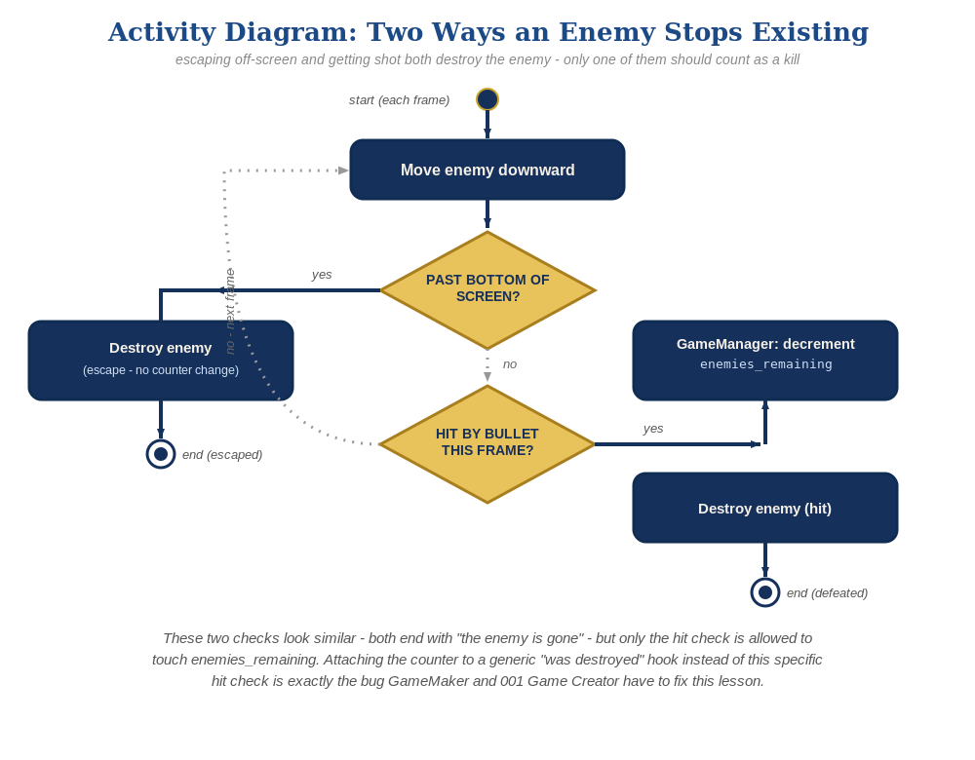
The general escape-vs-hit distinction behind this week's exercise - the same shape in every engine, whatever the exact code or blocks look like.
- Add a Create event to obj_enemy that sets enemy_speed = 1; and a Step event that uses it to move the instance downward, destroying it if it passes the bottom of the room (code below) - this is a plain destroy, unrelated to win-counting.
- On obj_bullet's existing Collision event with obj_enemy, add the win-counter decrement there instead, right alongside the existing instance_destroy() calls (code below) - this is the ONLY place enemies_remaining should ever change now, and it lives on obj_gamemanager, the dedicated manager object introduced in Lesson 6.
- Press F5 (Run) and let the enemies drift downward - shooting one should still work exactly as before, and letting one reach the bottom unshot should just destroy it, with no "You Win!" message.
// obj_enemy's Create event (new):
enemy_speed = 1;
// obj_enemy's Step event (new):
y += enemy_speed;
if (y > room_height) {
instance_destroy();
}
// obj_bullet's Collision event with obj_enemy (revised):
audio_play_sound(sfx_hit, 1, false);
obj_gamemanager.enemies_remaining -= 1;
if (obj_gamemanager.enemies_remaining <= 0) {
obj_gamemanager.has_won = true;
}
instance_destroy(other);
instance_destroy(self);
// obj_enemy's Destroy event: now empty - delete it, or leave it blank.

Alternate Path: GML Visual (no typing)
The same movement-and-cleanup pattern, and the same win-counter fix, work with drag-and-drop blocks instead of typed code.
- On obj_enemy's Create event, add a "Set Variable" block setting enemy_speed to 1. On obj_enemy's Step event, switch to GML Visual: a "Jump To Point" block (Movement category) with Relative checked for Y, X set to 0 and Y set to enemy_speed - prefer this purpose-built block over the generic Assign Variable/Set Variable for moving a built-in coordinate. Then an "If Variable" block comparing y against room_height, with an "Instance - Destroy Instance" block inside it.
- On obj_bullet's Collision event with obj_enemy, add the enemies_remaining blocks there (Set Variable targeting obj_gamemanager's enemies_remaining, If Variable checking <= 0), same as the code path.
- Delete any blocks remaining in obj_enemy's Destroy event.
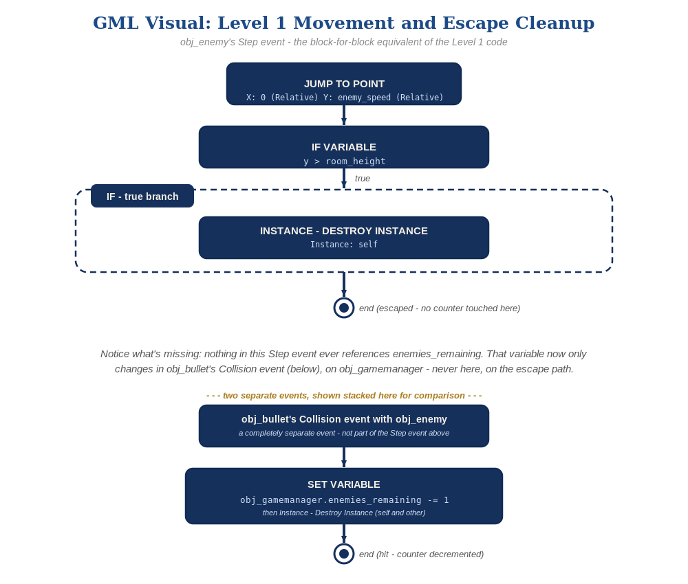
obj_enemy's Step event and obj_bullet's Collision event, in GML Visual - the block-for-block equivalent of the Level 1 code and the win-counter fix.
Level 2/3's escape-vs-hit distinction lives in which event contains the win-counter logic, the same in both paths.

Level 2 - Complete (Alpha/Beta)
A moving enemy can still be shot and destroyed correctly, and an enemy that escapes off the bottom never triggers "You Win!" by accident.
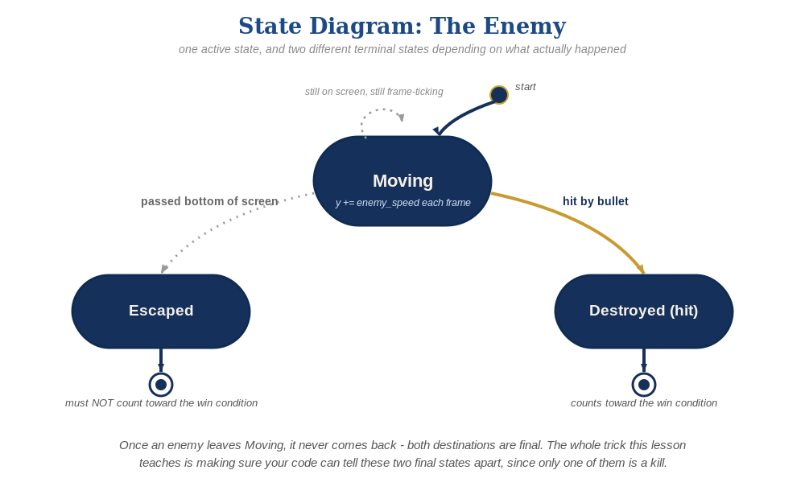
The enemy's two possible endings this week - only one of them should count as a kill.
- Shoot a moving enemy to confirm the Collision event still fires correctly while it's in motion.
- Let at least one enemy escape off the bottom unshot, and confirm "You Win!" does NOT appear - only obj_bullet's Collision event can ever change obj_gamemanager's enemies_remaining now, and the Step event's escape cleanup never touches it.

Level 3 - Refined (Ready to Publish) - pick any that interest you
- Visual: give each obj_enemy a slightly randomized enemy_speed in its Create event (e.g. enemy_speed = random_range(0.7, 1.3);) instead of the fixed value, so they don't all move in perfect lockstep.
- Structure: keep obj_enemy's Step event limited to movement and escape cleanup only - it should never reference or change enemies_remaining. That variable only ever changes from obj_bullet's Collision event, on obj_gamemanager, now.

If Something's Wrong
- "You Win!" appears even when enemies escaped unshot: this means the old Destroy-event decrement wasn't fully removed - double-check obj_enemy's Destroy event is actually empty.
- Enemies aren't destroyed when shot anymore: confirm the win-counter code was added to obj_bullet's Collision event, not accidentally left out when you moved it.
- Enemies don't move: confirm the Step event is attached to obj_enemy (not obj_spawner or obj_bullet), and that y += enemy_speed; actually runs every step with enemy_speed set in the Create event.

Want More?
Student Resource List > GameMaker section, or gamemaker.io/en/tutorials

